BACK TO MAIN TOC

Placing and Handling of Fabric Formed Concrete

Depth of Bleeding Effect

Fabrication of Fabric Molds
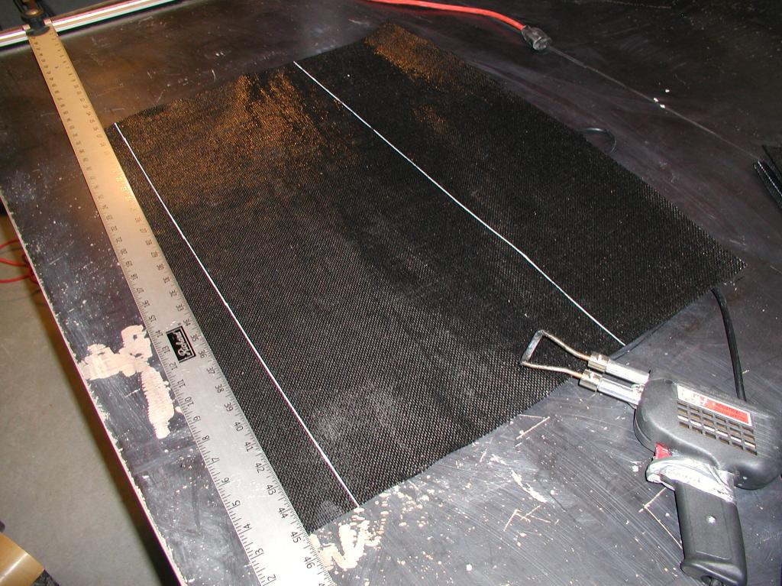Array
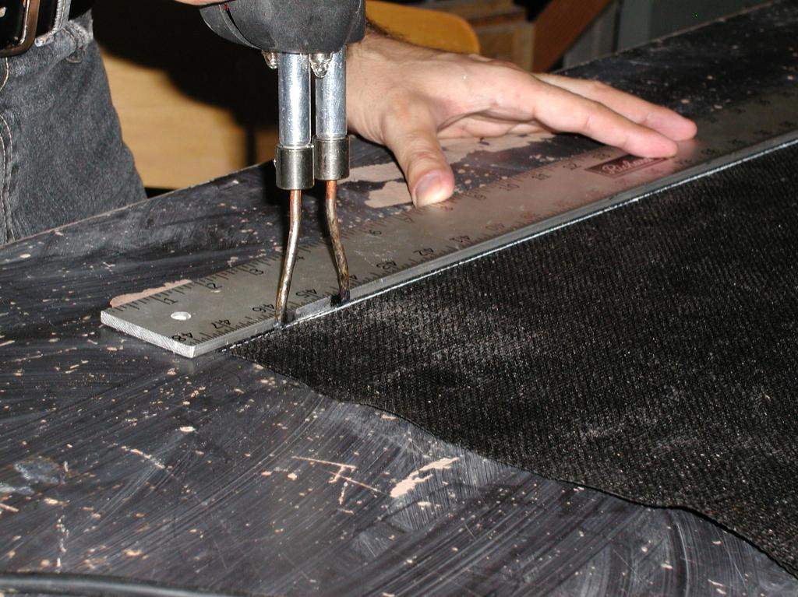Array
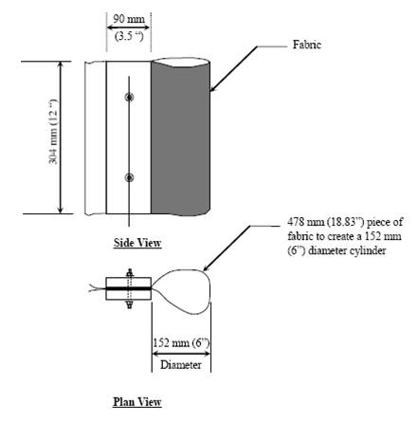Array
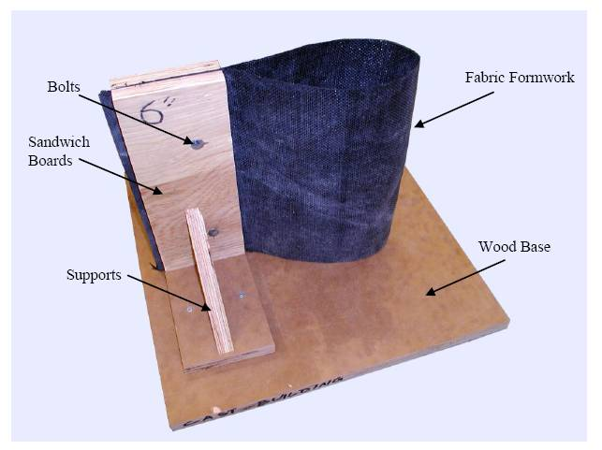Array
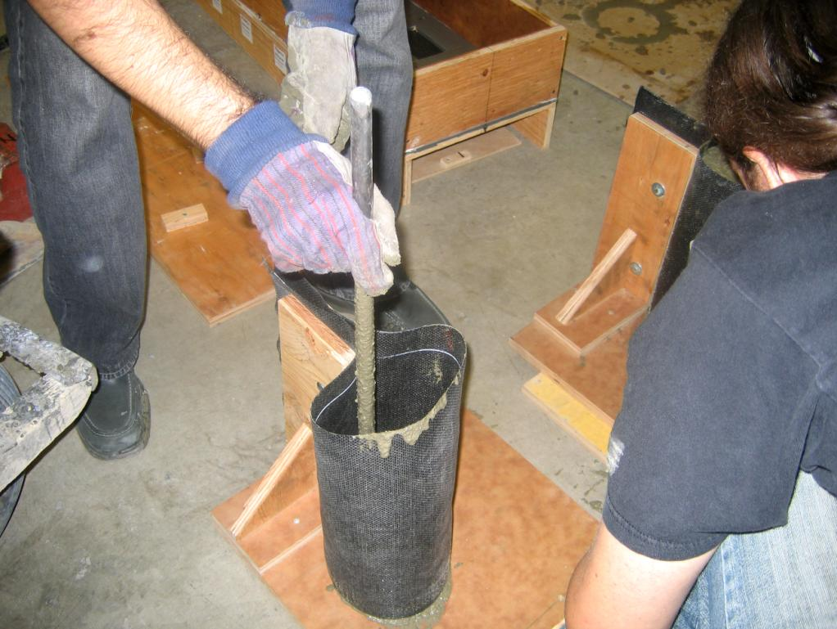Array
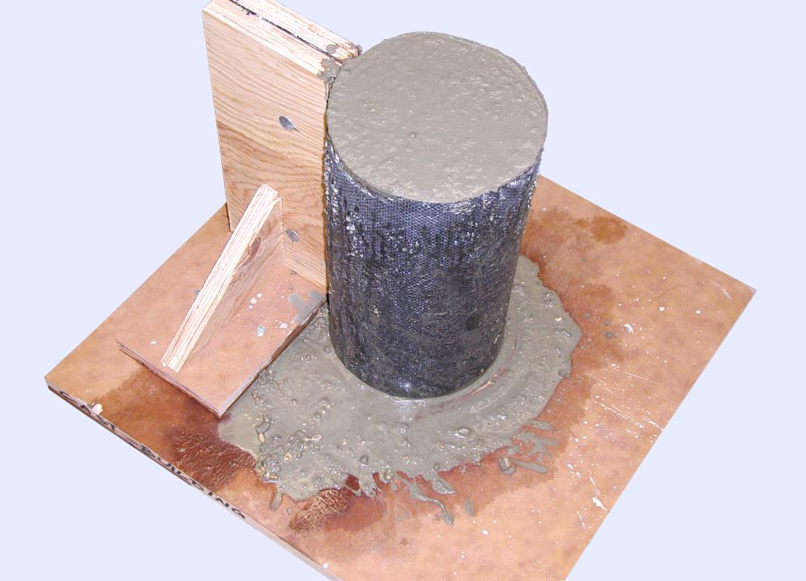Array
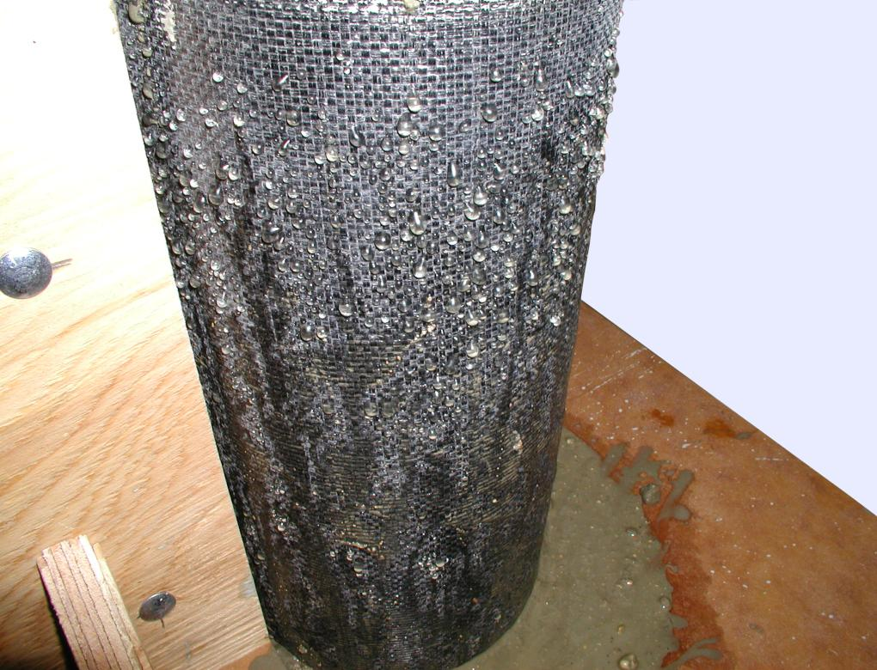Array
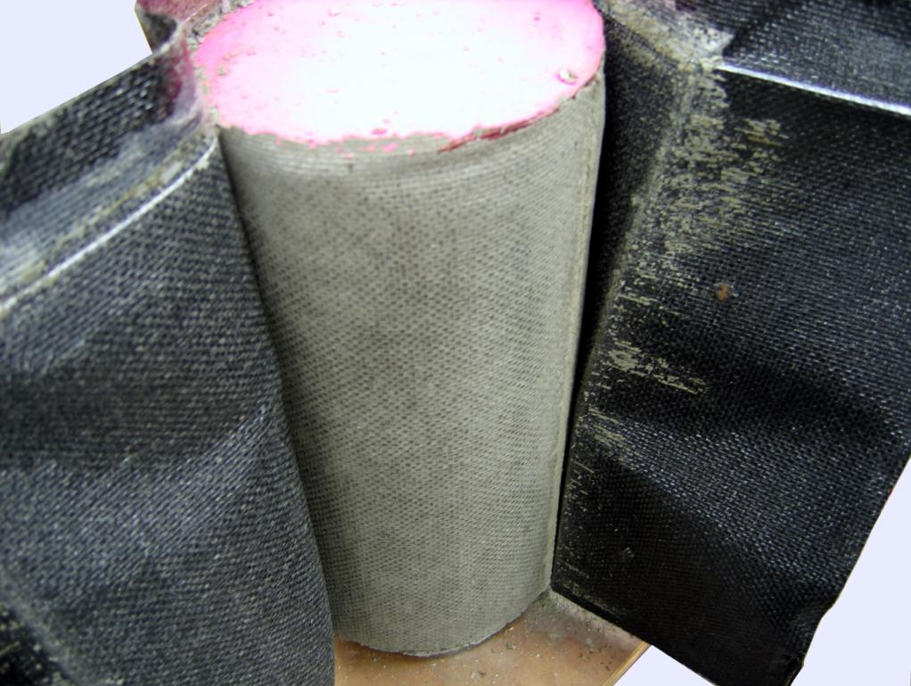Array
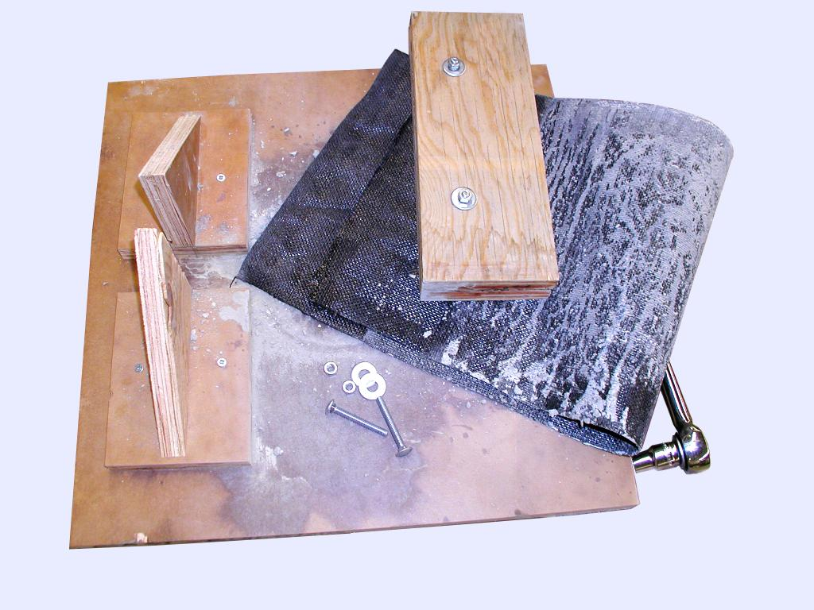Array

Bleeding Tests
Appendix B
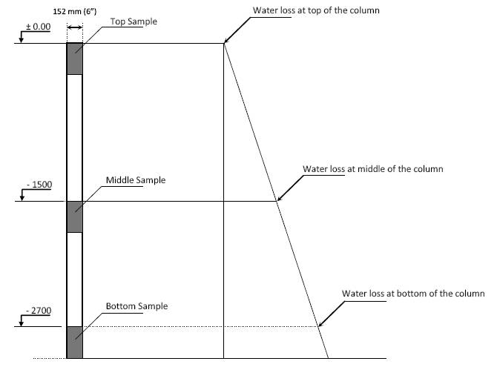Array
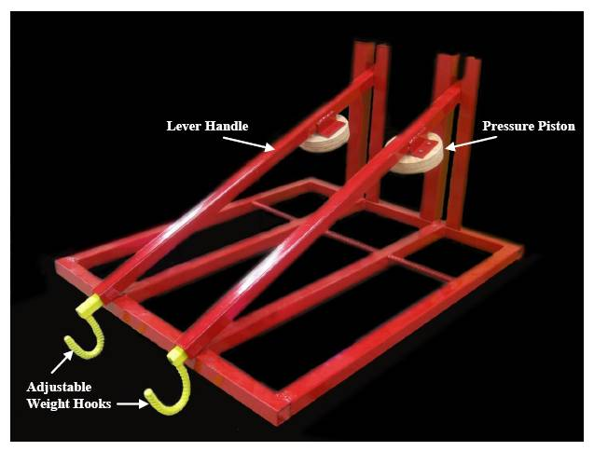Array
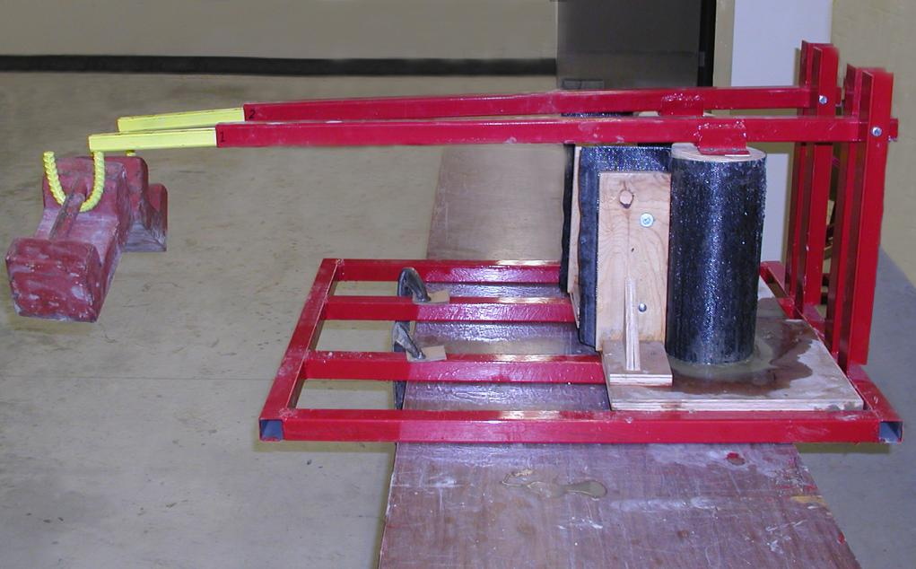Array
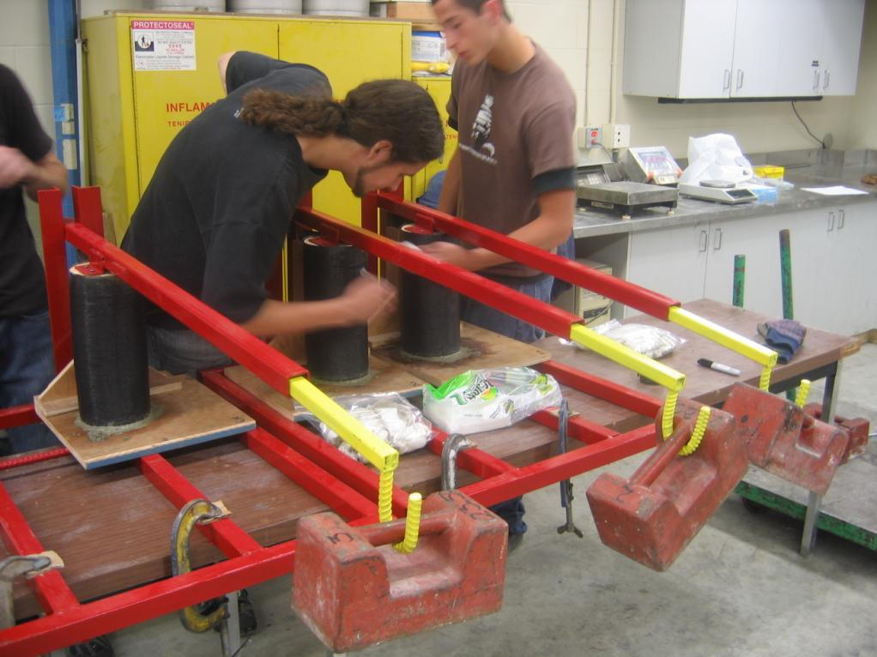Array
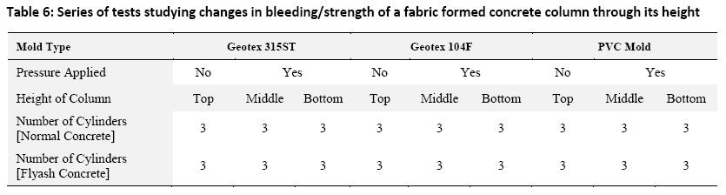Table 6: Series of tests studying changes in bleeding/strength of a fabric formed concrete column through its height

Test Results
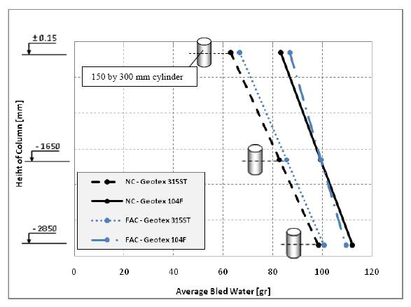Array
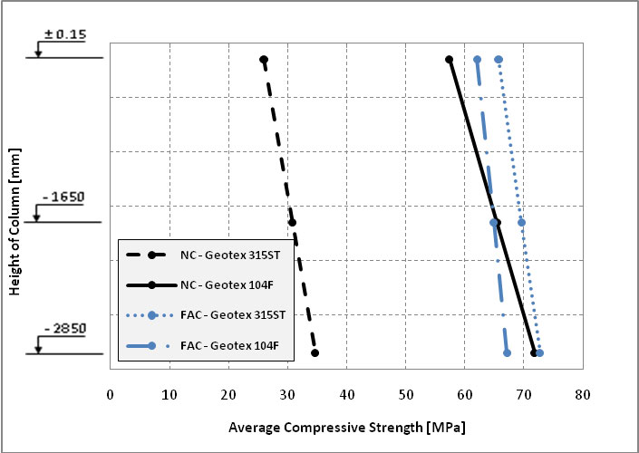Array
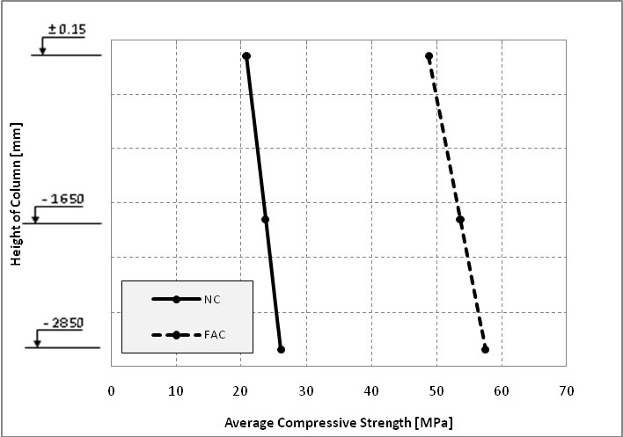Array

Finish Effect of Vibration on Concrete Surface

See Also
Place text here.

References
Use of Permeable Formwork in Placing and Curing Concrete.
Fab-Form Industries Ltd.http://fab-form.com/
Annual Book of ASTM Standards,
“”The Structural Engineer,
Design and Control of Concrete Mixtures.

External Links
Place text here.

