BACK TO MAIN TOC

Appendix A: Cost Analysis
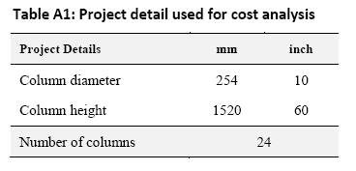Table A1: Project detail used for cost analysis
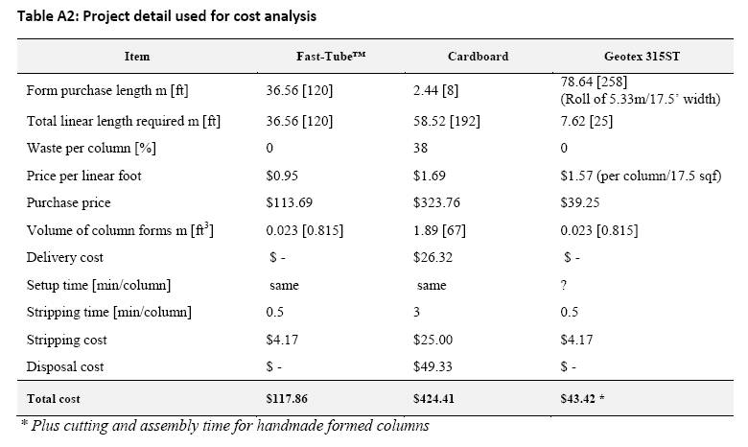Table A2: Project detail used for cost analysis
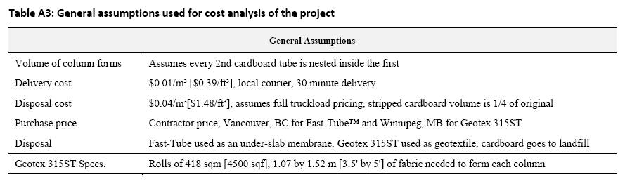Table A3: General assumptions used for cost analysis of the project
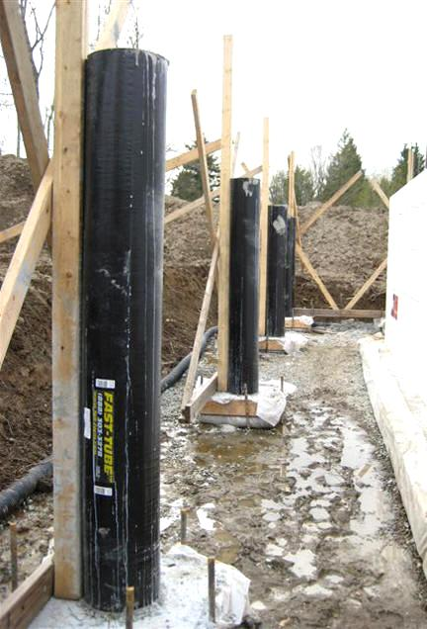Array
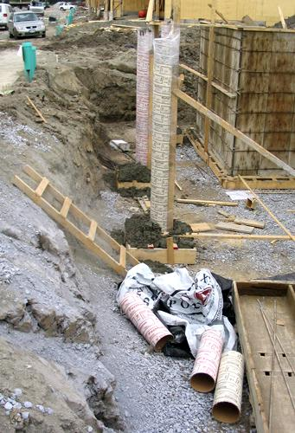Array

See Also
Place text here.

References
Fab-Form Industries Ltd.http://fab-form.com/

